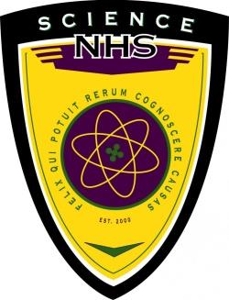
SKYLINE CHAPTER OF SCIENCE NATIONAL HONOR SOCIETY (SNHS)

About SNHS
SNHS is a prominent scientific organization that will engender a new group of young thinkers who will be the future of industry, research, and scientific exploration for America.
We pledge to:
- Encourage and recognize scientific and intellectual thought
- Advance the students’ knowledge of classical and modern science
- Communicate with the scientific community
- Aid the civic community with its comprehension of science
- Encourage students to participate in community service and in turn, encourage a dedication to the pursuit of scientific knowledge that benefits all humankind

Meetings
- Conduct science experiments
- Collaborate with other science clubs such as Biology Club, Tech Club, etc.
- Guest Speakers
- Tutor
- Help science teachers

Eligibility Requirements
- Current sophomore or junior at Skyline
- Cumulative 3.5 GPA and 3.7 GPA in science courses (out of a 4.0 scale)
- Clear disciplinary record
- Taken at least one science class
- Taken or plan to take an IB science class
*Membership is limited to 30 juniors and 30 seniors.
*All potential members MUST submit an application to be considered for admission.

Membership Requirements (for those that are accepted)
- Academic Requirements
  - Active members MUST maintain a cumulative 3.5 GPA overall and cumulative 3.7 GPA in science courses.
- Attendance Requirements
  - We will have 2 meetings per month after school on Fridays.
  - Members must attend a minimum of one meeting per month.
  - Only one absence per year (not coming for any of the meetings that month) is permitted.
- Service/Educational Requirements:
Active members must complete a minimum of 25 hours of community service total each year with a minimum in the following categories:
  - Science Hours (6 hours per semester)
  - Science Clean-Up/Lab Preparation (2 hours per semester)
  - Individual Hours (any form of community service)
- Pay SNHS dues $25 per year of membership (subject to change)

PLEASE NOTE: Failure to comply with these requirements will result in dismissal from Science National Honor Society.

